## INDUSTRIAL TRAINING REPORT

**EGATOR WEBSITE**

### Submitted in the partial fulfillment of the

### Requirements the award of

### Degree of Bachelor of Technology in Computer Science and Engineering

### Submitted By

### Name: Nancy Kumari

### University Roll No. : 00614807221

### SUBMITTED TO: DR. ANKITA GUPTA

### Department of Computer Science & Engineering

**MAHARAJA AGRASEN INSTITUTE OF TECHNOLOGY**

**GGSIPU,DELHI**

**CERTIFICATE**

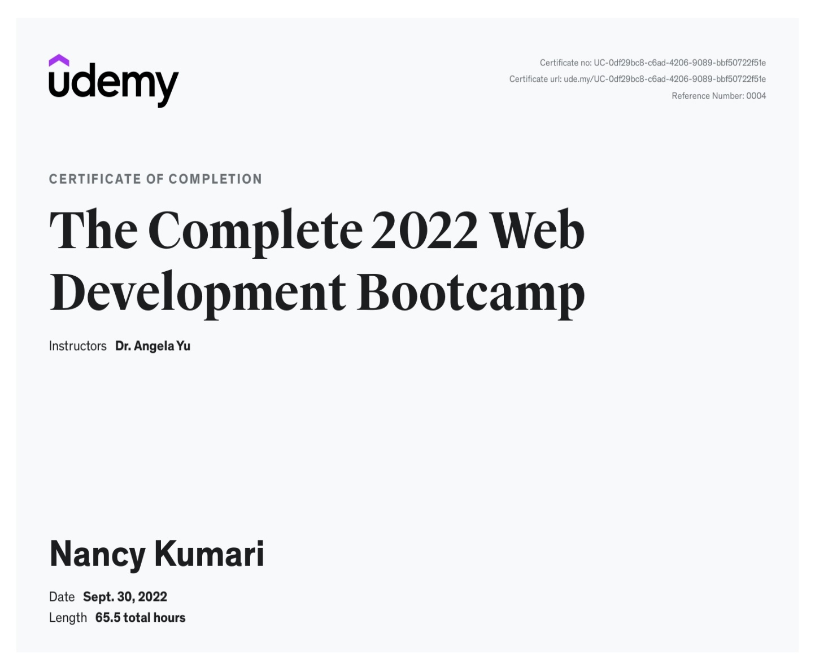

**DECLARATION**

I hereby declare that the Training Report entitled “**EGATOR WEBSITE**” is an authentic record of my own work as requirements of **6 weeks** Training during the period from **10 August to 30 September** for the award of degree of B.Tech. (Computer Science & Engineering), GGSIPU, under the guidance of **Dr. Angela Yu.**

**Nancy Kumari**

**00614807221**

Date:

Certified that the above statement made by the student is correct to the best of our knowledge and belief.

**Signatures**

**Examined by:**

1. 2.

**(Guide/Trainer)**  **(Faculty Coordinator)**

**Head of Department**

**(Signature and Seal)**

**AKNOWLEGDEMENT**

Firstly, I would like to express my profound gratitude to Dr. Angela Yu, who conducted the online training over Udemy as instructor and taught exceptionally well. Her videos were extremely knowledgeable and helped me learn the basics of Web Development which I was previously afraid of.

Secondly, I would like to thank Udemy for providing such an amazing platform for the students to learn, grow, and test their skills. Even though we are suffering from the Corona Pandemic, this lockdown turned out to be the perfect time to learn, revise and enhance my skills. I wish to thank my respected faculty members and my classmates for their support during this tough time and for reminding me that the process of learning is governed by us.

I am very grateful that my parents could afford buying me a course during this time along with showing their support even when we faced many hardships when we suffered from the deadly virus.

**Organization Profile**

**Udemy**

Udemy is one of the leading world-wide online learning marketplaces (e- learning). More than 9 million students participate worldwide. With more than 80,000 courses most topics are covered and taught by experts. The courses are available on demand so that the learning is possible anywhere at any time, on the own pace. Udemy courses are available in 80 languages. Instruction is delivered by teachers from universities and colleges but by removing the university name and accreditation process it makes top quality training much more affordable. Offering more than 80,000 online courses with many available free of charge, there is definitely something for everyone from business to personal interests. Udemy has redesigned its platform making e-learning an enjoyable experience through up to date and fully functional online tools. The modern search facility allows students faster answers to questions and quizzes make for an engaging hands-on experience.

By entering the website, you have the menu bar on the left side. You can sort the offered courses by language with the menu bar. Then you can check all the offered courses and filter them by subject. Prices are low with discounts every month and fees are charged per course rather than monthly which means you only pay for what you need. Purchased courses can be saved off-line meaning one payment gives you the keys to your future. Payments can be affected with the mobile app that uses Apple’s or Google Play’s payment system depending on the device, often in your local currency. For all offered topics there are also free courses available! To start with Udemy, you can first try a free course too.

**Mission and Vision:**

• We work at a purpose-driven company that places a high value on results, so we can continue to grow and give as many people as possible access to learning resources. We immerse ourselves in data and communicate directly with our instructors and students to ensure we’re making real progress toward our goals and theirs.

• With a mission to improve lives through learning, it’s no surprise that we place tremendous emphasis on the role of learning in our own lives and work. We understand that learning isn’t an interruption of our work or a sign of weakness—it’s foundational to our growth, both as individuals and as a business.

• Individuals make great contributions, but it takes collaboration, compromise, and kindness to build a great business. We succeed as a team, leave our egos at the door, and take pride in our shared efforts.

• We embrace our quirks and bring our whole selves to work. We recognize that it’s our differences that produce the best work, not conformity, so we are excited to welcome coworkers with varied backgrounds, experiences, identities, and ideas. Our openness allows us to better serve the diverse people who use Udemy across the globe.

Udemy is a platform that allows instructors to build online courses on their preferred topics. Using Udemy's course development tools, they can upload videos, PowerPoint presentations, PDFs, audio, ZIP files and live classes to create courses. Instructors can also engage and interact with users via online discussion boards. Courses are offered across a breadth of categories, including business and entrepreneurship, academics, the arts, health and fitness, language, music, and technology. Most classes are in practical subjects such as Excel software or using an iPhone camera. Udemy also offers Udemy for Business, enabling businesses access to a targeted suite of over 7,000 training courses on topics from digital marketing tactics to office productivity, design, management, programming, and more. With Udemy for Business, organizations can also create custom learning portals for corporate training. Courses on Udemy can be paid or free, depending on the instructor. In 2015, the top 10 instructors made more than $17 million in total revenue. In April 2013, Udemy offered an app for Apple iOS, allowing students to take classes directly from iPhones; The Android version was launched in January 2014. As of January 2014, the iOS app had been downloaded over 1 million times, and 20 percent of Udemy users access their courses via mobile. In July 2016, Udemy expanded their iOS platform to include Apple TV. On January 11, 2020, the Udemy mobile app became the #1 top grossing Android app in India.

**TABLE OF CONTENT**

CHAPTER 1: Introduction

1a. The objective of industrial training…………………………

1b. The objective of industrial training report………………….

CHAPTER 2: Tool & Technology Used

2a. Code pen……………………………………………………

2b. Visual Studio Code…………………………………………

2c. Netlify………………………………………………………

CHAPTER 3: Technical Contents

3a. Web Development…………………………………………

3b. Importance of web Development………………………….

3c. HTML……………………………………………………...

3d. CSS………………………………………………………...

3e. JavaScript…………………………………………………..

3f. Iconscout.com……………………………………………....

3g. Training Period……………………………………………..

3h. Project Structure…………………………………………....

CHAPTER 4: Snapshots

CHAPTER 5: Results and Discussions

5a. Result……………………………………………………...

5b. Discussions………………………………………………..

CHAPTER 6: Conclusions and Future Scope

6a. Conclusions………………………………………………..

6b. Future Scope……………………………………………….

CHAPTER 7: Weekly Jobs Summary

**Learning after Training………………………………………….**

**References…………………………………………………………**

**CHAPTER-1**

**Introduction**

#### **1a. The objective of industrial training**

Industry training is a major component of the extra-curricular learning in engineering. The students are required to pass before the Industrial Training is recommended for award of a degree at any engineering college. The students will be placed in government departments or private companies for 6 weeks to expose them to a real work environment and different from the atmosphere at the college.

Often students will be faced with many challenges and problems that have not been confronted. The main purpose of this training was to expose

students to the real working environment when the students leave the college later.

Students also have the opportunity to use all the knowledge and theories related to courses taken while at the engineering course of industrial training and provide opportunities for students to use the fruit of a creative mind for the good of the firm and indirectly for their own benefit as well. Thus, there has been this experience, maybe it can help students to study in the following semester and a real working environment. Students also can be exposed to ways to communicate well, expanding relationships between partners of the workplace and the people around, foster teamwork and good relations with industrial workers where this at once can cause a sense responsible to a trust (work) and balance as well as from all aspects.

In conclusion, the objective of the training period is to:

* To expose students to the real working environment.
* Let’s students see the connection between theoretical learning with practical work.
* Adopt and comply with safety regulations in the industry.
* Establish and strengthen confidence in the performance of duties.
* Instill teamwork and good relationships with other employees.
* Ability to assess themselves to prepare for the working world after graduation.
* Raise awareness and increase student interest in the subject selected.

**1b.** **The objective of industrial training report**

Some objectives can be defined and made known in this industrial training report are described as follows:

1. Be evidence that the student has been training by a predetermined time period.
2. Record all activities during the training period.
3. A reference in the future.
4. It proves that students understand and appreciate the work done during Industrial Training.

As a reference after the training period in the firm after completing their studies at the Polytechnic

**CHAPTER-2**

**Tool & Technology Used**

**2a. CodePen**

****CodePen is a social development environment. At its heart, it allows you to write code in the browser, and see the results of it as you build. A useful and liberating online code editor for developers of any skill, and particularly empowering for people learning to code. We focus primarily on front-end languages like HTML, CSS, JavaScript, and preprocessing syntaxes that turn into those things. We say social, because CodePen is a community. Most creations on CodePen are public and open source. They are living things that other people and the community can interact with, from a simple hearting, to leaving a comment, to forking and changing for their own needs. People use CodePen for all sorts of things: prototyping new ideas, reduced test cases for bugs, sending clients things to look at, evaluating potential hires, to finding inspiration. People also use CodePen as a sort of resume and portfolio, showing off their best design and development work.

**2b. Visual Studio Code**

****Visual Studio Code for the Web provides a free, zero-install Microsoft Visual Studio Code experience running entirely in your browser, allowing you to quickly and safely browse source code repositories and make lightweight code changes. To get started, go to <https://vscode.dev/> in your browser. VS Code for the Web has many of the features of VS Code desktop that you love, including search and syntax highlighting while browsing and editing, along with extension support to work on your codebase and make simpler edits. In addition to opening repositories, forks, and pull requests from source control providers like GitHub and Azure Repos (in preview), you can also work with code that is stored on your local machine. VS Code for the Web runs entirely in your web browser, so there are certain limitations compared to the desktop experience.

**2c. Netlify**

Netlify is next-generation automation and web hosting platform that helps in enhancing your productivity in the best way possible. It simplifies the developers’ process to deploy as well as host a site. It is way easier for an eCommerce website development service without spending too much effort or time with its amazing features. Netlify is a San-Francisco-based company that works on web hosting infrastructure and automation technology. The platform offers a faster way to ensure increased scalability, performance, and secure websites and apps from the local development process to advanced logic. The website industry is rapidly changing from monolithic approaches to decoupled approaches. The developers are also storming ahead with more power than before. Therefore, the Netlify platform has been developed to offer web automation technology and web hosting where developers can build, test, and deploy websites. Not only developers but digital marketers and editors get an advantage from the platform too. The best part is Netlify is available in an affordable range. Main Features of Netlify are as follows:

1. Hosting Using Netlify, one can effectively host static websites, ensuring better performance, speed, scalability, and security. You do not need to pay to get custom domain name support. You can also stand out with HTTPS and custom domain names using Netlify. With less price, it offers various interesting services.

2. Forms For getting information from your users, creating forms is necessary. Fortunately, Netlify provides a submission feature to let you get users’ information through a simple lambda function.

**CHAPTER-3**

**Technical Contents**

**3a. Web Development**

Web development is the work involved in developing a Website for the Internet (WWW) or an internet (a private network). Web development can range from developing a simple single static page of plain text to complex web application, electronic businesses, and social network services. A more comprehensive list of tasks to which Web development commonly refers, may include Web engineering, Web design, Web content development, client liaison, client-side/server-side scripting, Web server and network security configuration, and e-commerce development.

For larger organizations and businesses, Web development teams can consist of hundreds of people (Web Developers) and follow standard methods like Agile methodologies while developing Web sites. Smaller organizations may only require a single permanent or contracting developer, or secondary assignment to related job positions such as a graphic designers or information system technician. Web development may be a collaborative effort between departments rather than the domain of a designated department. There are three kinds of Web developer specialization: front-end developer, back-end developer, and full-stack developer. Front-end developers are responsible for behavior and visuals that run in the user browser, while back-end developers deal with the servers.

#### **Types of Apps:**

Web designing is of three kinds, to be specific static, dynamic or CMS and eCommerce. Picking the sort of website design relies upon the kind of business and necessity of the entrepreneurs. Every one of these sites and be designed and developed on various platforms.

**Static website design**– When you simply need a couple of pages on your site and don't need the data to change, a static design is the best. The info on a static site continues as before and has no changes occurring in the course of time. Static websites are made in HTML, CSS and Java.

**CMS or dynamic website-** A dynamic website design can convey dynamic

data. This implies relying upon changes occurring; the site data are updated automatically depending on a couple of criteria. Its design is created on content management platform or CMS like WordPress, Joomla and so on.

**eCommerce website-** In the event that you have a store which involves sales, then you need an eCommerce website or e-store. A decent eCommerce platform encourages you to deal with all the technical parts of the website. There are a large number of platforms where you can design an eCommerce site like Opencart, Woocommerce, Zencart, Magento, OsCommerce and so on.A website for a small business should have a distinctive look that can differentiate it from any other sites on the Internet. This is a good design for businesses that cannot afford a professional web designer.Visitors should be able to get from one place to another by using different ways. The design should allow for this. If you want a reliable website design, consider using a content management system. A CMS provides a website that offers flexibility in designing, creating and updating content.In order to provide more functionality, the design should include different elements such as a navigation bar and a page editor. These two elements allow users to edit pages without having to worry about breaking the site. The layout should be simple and easy to navigate. It should not be hard to find the information needed for the business, and the design should allow for easy information sharing among employees.This type of website design is perfect for those who do not want to spend a lot of money on a website. Because it is less complex, a person or business can use it to create a personal website that will serve its purpose.

#### **3b. Importance of Web Development**

Website development is a way to make people aware of the services and/or products you are offering, understand why your products are relevant and even necessary for them to buy or use, and see which of your company's qualities set it apart from competitors.

Displaying this information with high-quality images and thought-out presentation will have a large influence on customers, and it is important to strive towards making your product as relatable and appealing as possible. Additionally, with website development you can:

Communicate with your visitors effectively. Interacting with your audience is vital when it comes to generating more business. It is viable to make a website that enables you to get in touch with your customers and prospects, and you can produce valuable content for the audience associated with the industry or business you're in. Afterwards, post the content on your blog, share it on social media networks and respond to customers' comments and feedback promptly. This will show your clients the extent to which you’re concerned about their satisfaction and responsive to their needs.

* Improve your connectivity. A website will facilitate things like expanding your reach and attracting more visitors to your business. Planning to make a responsive website design for your site will help make it accessible to an extensive range of users spanning several devices, such as tablets or smartphones. This will increase both your site's exposure and organic traffic.
* Prove your reliability. A website offers a straightforward method of showing the credibility of a business, and the way a person represents his business online is vital for attracting more customers or visitors. Therefore, your website design should be handled in the best possible way, because a professional presentation speaks volumes as testimony to your business. With the help of website development, you can add your skills, credentials, experience, expertise and more in a single place. These details help you earn the trust and confidence of your visitors and serve as a reference point for customers interested in your business, making it easy for you to produce leads.

**3c. HyperText Markup Language (HTML)**

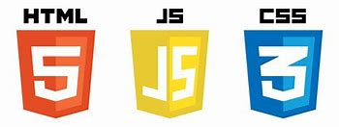HTML is an acronym which stands for **Hyper Text Markup Language** which is used for creating web pages and web applications. Let's see what is meant by Hypertext Markup Language, and Web page.

**Hyper Text:** HyperText simply means "Text within Text." A text has a link within it, is a hypertext. Whenever you click on a link which brings you to a new webpage, you have clicked on a hypertext. HyperText is a way to link two or more web pages (HTML documents) with each other.

**Markup language:** A markup language is a computer language that is used to apply layout and formatting conventions to a text document. Markup language makes text more interactive and dynamic. It can turn text into images, tables, links, etc.

## Features of HTML

## It is a very **easy and simple language**. It can be easily understood and modified.

## It is very easy to make an **effective presentation** with HTML because it has a lot of formatting tags.

## It is a **markup language**, so it provides a flexible way to design web pages along with the text.

## It facilitates programmers to add a **link** on the web pages (by html anchor tag), so it enhances the interest of browsing of the user.

## It is **platform-independent** because it can be displayed on any platform like Windows, Linux, and Macintosh, etc.

## It facilitates the programmer to add **Graphics, Videos, and Sound** to the web pages which makes it more attractive and interactive.

## HTML is a case-insensitive language, which means we can use tags either in lowercase or upper-case.

## Structure of HTML

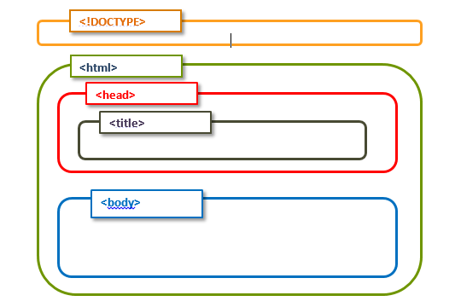

**<!DOCTYPE>:** It defines the document type or it instruct the browser about the version of HTML.

**<html >** :This tag informs the browser that it is an HTML document. Text between html tag describes the web document. It is a container for all other elements of HTML except <!DOCTYPE>

**<head>:** It should be the first element inside the <html> element, which contains the metadata(information about the document). It must be closed before the body tag opens.

**<title>:** As its name suggested, it is used to add title of that HTML page which appears at the top of the browser window. It must be placed inside the head tag and should close immediately. (Optional)

**<body>**: Text between body tag describes the body content of the page that is visible to the end user. This tag contains the main content of the HTML document.

**Anatomy of HTML**

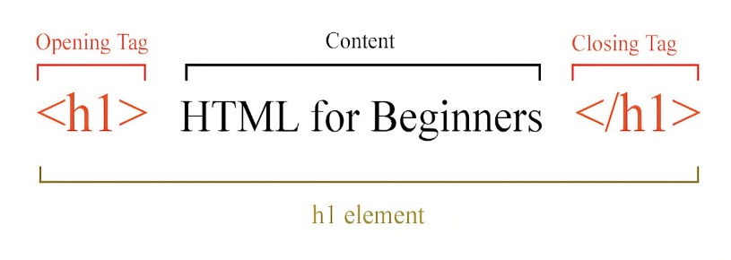

**<h1>** : Text between <h1> tag describes the first level heading of the webpage.

**HTML BOILERPLATE CODE**

<!DOCTYPE html>

<html lang="en">

<head>

<meta charset="UTF-8">

<meta name="viewport" content="width=device-width, initial- scale=1.0">

<title>HTML 5 Boilerplate</title>

<link rel="stylesheet" href="style.css">

</head>

<body>

<script src="index.js"></script>

</body> </html>

**LANG ATTRIBUTE:**

The lang attribute inside the opening <html> tag sets the language for the page.

###### **UTF-8:**

UTF-8 is the standard character encoding you should use in your web pages.

###### **CSS STYLESHEET COMMAND:**

This code will link your custom CSS to the HTML

page. rel="stylesheet" defines the relationship between the HTML file and the external stylesheet.

###### **Script tags in HTML:**

External script tags will be placed just before the ending body tag. This is where you can link your external JavaScript code.

**3d. Cascading Style Sheets**



(**CSS**) is a Style sheet language used for describing the presentation of a document written in a markup language. HTML, CSS is a cornerstone technology of the WWW alongside HTML and JavaScript.

CSS is designed to enable the separation of presentation and content, including layout, colors.

and fonts. This separation can improve content accessibility, provide more flexibility and control in the specification of presentation characteristics, enable multiple web to share formatting by specifying the relevant CSS in a separate .css file which reduces complexity and repetition in the structural content as well as enabling the .css file to be cached to improve the page load speed between the pages that share the file and its formatting.

The CSS specifications are maintained by the (W3C).

**Syntax:**

CSS has a simple syntax and uses a number of English keywords to specify the names of various style properties.

* A CSS rule consists of a selector and a declaration block.
* The selector points to the HTML element you want to style.
* The declaration block contains one or more declarations separated by semicolons.
* Each declaration includes a CSS property name and a value, separated by a colon.
* Multiple CSS declarations are separated with semicolons, and declaration blocks are surrounded by curly braces.

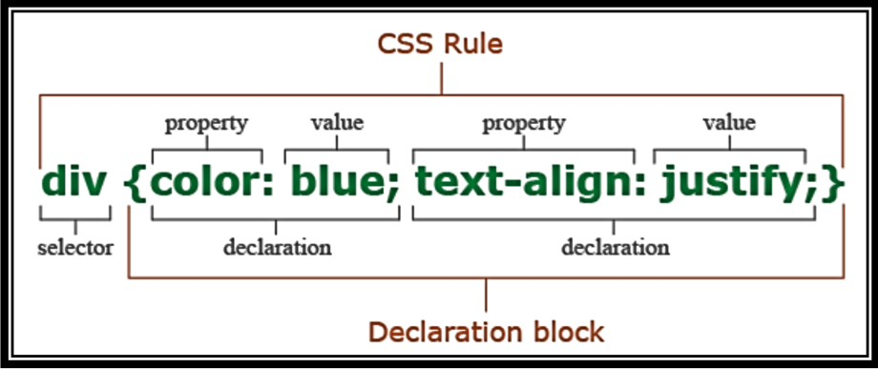**Selector:** Selector indicates the HTML element you want to style. It could be any tag like <h1>, <title> etc.

**Declaration Block:** The declaration block can contain one or more declarations separated by a semicolon. For the above example, there are two declarations:

1. color: blue ;
2. text-align: justify;

**Property:** A Property is a type of attribute of HTML element. It could be color, border etc.

**Value:** Values are assigned to CSS properties. In the above example, value "yellow" is assigned to color property.

**CSS Box Model:** In CSS, the term "box model" is used when talking about design and layout. The CSS box model is essentially a box that wraps around every HTML element. It consists of: margins, borders, padding, and the actual content.

The image below illustrates the box model:

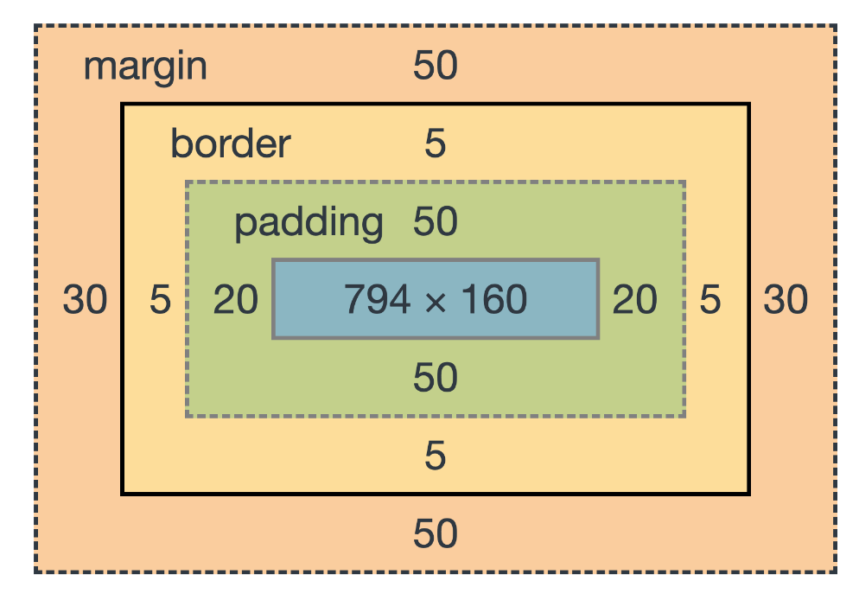

Explanation of the different parts:

* **Content** - The content of the box, where text and images appear
* **Padding** - Clears an area around the content. The padding is transparent
* **Border** - A border that goes around the padding and content
* **Margin** - Clears an area outside the border. The margin is transparent The box model allows us to add a border around elements, and to define space between element.

**3c. JavaScript**

JavaScript (js) is a light-weight object-oriented programming language which is used by several websites for scripting the webpages. It is an interpreted, full-fledged programming language that enables dynamic interactivity on websites when applied to an HTML document. It was introduced in the year 1995 for adding programs to the webpages in the Netscape Navigator browser. Since then, it has been adopted by all other graphical web browsers. With JavaScript, users can build modern web applications to interact directly without reloading the page every time. The traditional website uses js to provide several forms of interactivity and simplicity.

**Features of JavaScript**

There are following features of JavaScript:

1. All popular web browsers support JavaScript as they provide built-in execution environments.
2. JavaScript follows the syntax and structure of the C programming language. Thus, it is a structured programming language.
3. JavaScript is a weakly typed language, where certain types are implicitly cast (depending on the operation).
4. JavaScript is an object-oriented programming language that uses prototypes rather than using classes for inheritance.
5. It is a light-weighted and interpreted language.
6. It is a case-sensitive language.
7. JavaScript is supportable in several operating systems including, Windows, macOS, etc. It provides good control to the users over the web browsers.

## DOM (Document Object Model)

DOM is a way to represent the webpage in a structured hierarchical way so that it will become easier for programmers and users to glide through the document. With DOM, we can easily access and manipulate tags, IDs, classes, Attributes, or Elements of HTML using commands or methods provided by the Document object. Using DOM, the JavaScript gets access to HTML as well as CSS of the web page and can also add behavior to the HTML elements. so basically **Document Object Model is an API that represents and interacts with HTML or XML documents.**

Why called an Object Model?  
Documents are modeled using objects, and the model includes not only the structure of a document but also the behavior of a document and the objects of which it is composed like tag elements with attributes in HTML.

**3f. Iconscout.com**

Iconscout is a digital resource marketplace. On the platform, you can get free and premium icons, illustrations and stock photos. Currently, Iconscout has more than 2 Million assets from 500+ Contributors globally. Iconscout has a plugin Icondrop for the majority of the tools like Sketch, Adobe (XD, Illustrator & Photoshop), Microsoft (Office & Powerpoint), Gsuite (Docs & Slides). Using this plugin you can directly get millions of assets in your tool. You don’t need to visit the platform to download any asset.

Unicons is a free library of 1000+ vector icons across 20+ categories. These icons can also be used as a web font. You can customize size, color and tone of each icon.

Icons are available in top categories like User Interface, Communication, Business, Medical, etc. All the icons are carefully crafted in 24px grid to have consistency on all kind of display. With Pixel-Perfect detailing for each icon, it is easy to scale the icon for all screen sizes without compromising for sharpness.

**3g. Training Period**

During the training period, my main job was to learn about the course content which is front-end development including the HTML, CSS and JavaScript and to practically implement these concepts. So, to implement it practically, I had to develop a project based on these things.

##### **Setting up the things**

So, my work is the creation of project, I had to first think about the project structure and basic needs and necessities of the project like what are the basic things inside a food ordering website, for example: navigation bar, different web pages linked together, proper presentation, elements like footer, etc.

##### **Ordering the content**

After thinking about all these basic requirements, I had to figure out the design of the website that is, where should I place navigation bar, logo and icons, contact form and all.

##### **Designing phase**

After that, website interface was created, which encompasses small details like color combinations, design of the buttons and icons, things to be included to make site look realistic etc.

##### **Folder Structuring**

Then the folder structure is created, which means that proper locations to the files are assigned like CSS files placed in different folder, image files allotted a different folder, HTML files placed in yet another folder. This must be done in order to keep the folders sorted and ready whenever you need them.

**3h. Project Structure**

The project is a education website implemented using Front-End Development. Project title is "EGATOR WEBSITE". As the name suggests it helps you to find different courses and ask your doubt from home. The website consists of home, about, contact and courses pages where we can see all the details of courses and contact to us and with the help of netlify all contact information is stored so I can see who ask doubt or query.

### File Structure:

### The project consists of a number of files:

### 

###### Index.html

###### This file is the main and central file of the project. This file contains the HTML code and code to include other files as well. This file contains all the code which is practically visible to us on the site.

###### Styles.css

Contains the various css commands to beautify the homepage.

###### About.html

Contains HTML code for about page

###### About.css

Beautify about page with help of about.css

* Contact.html

Contains contact detail for courses

* Contact.css

For Designing of contact page use this file

* Courses.html

This file used for courses

* Main.js

It is used to add features in the project

* Images

It contained all the images of the project.

###### **CHAPTER-4**

**Snapshots**

The website is divided in 4 pages:

* + Home
  + About
  + Contact
  + Courses

These pages are further divided in sections

#### **Page-1: Home**

###### Navigation bar:

This section contains the navigation bar which sticks to the top of the screen even if you scroll down. It displays various section which can be clicked to access that particular section.

* Home

This section has the welcome information and brief detail about courses and doubt.

###### Footer bar

This section has contact detail.

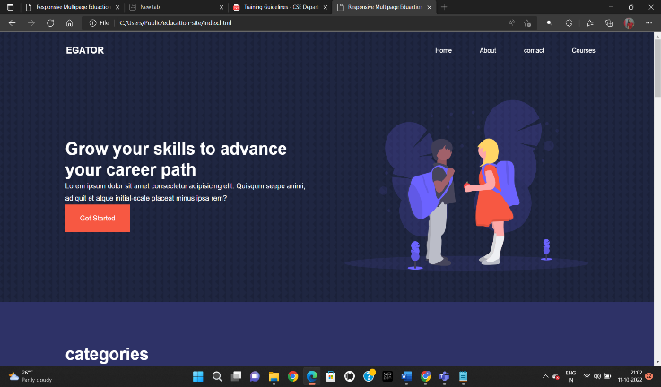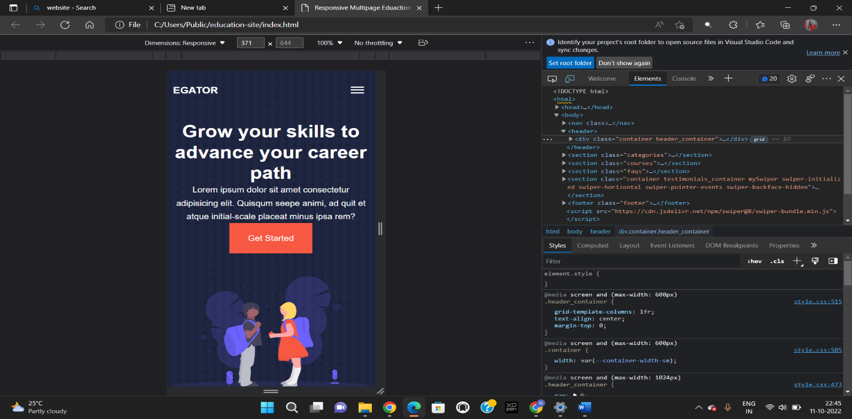

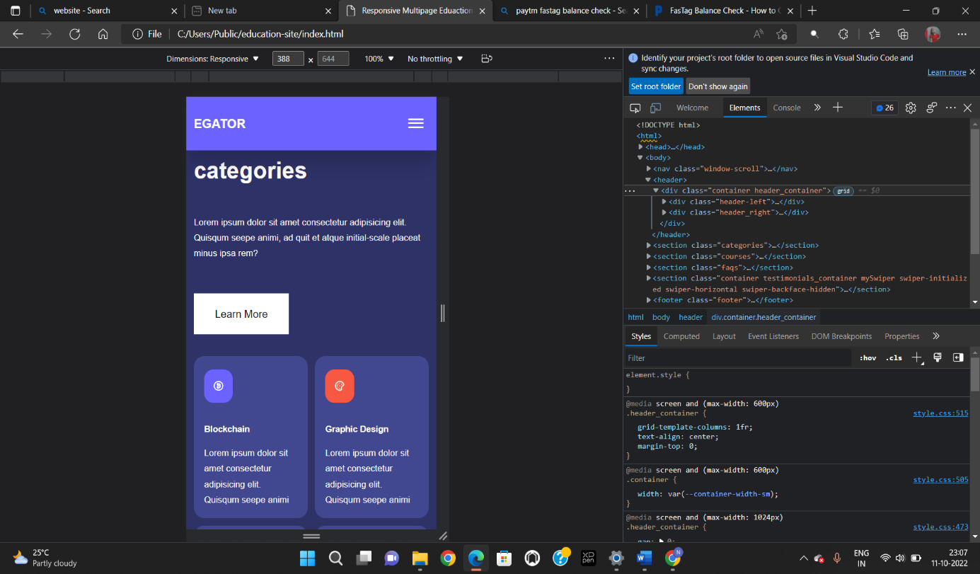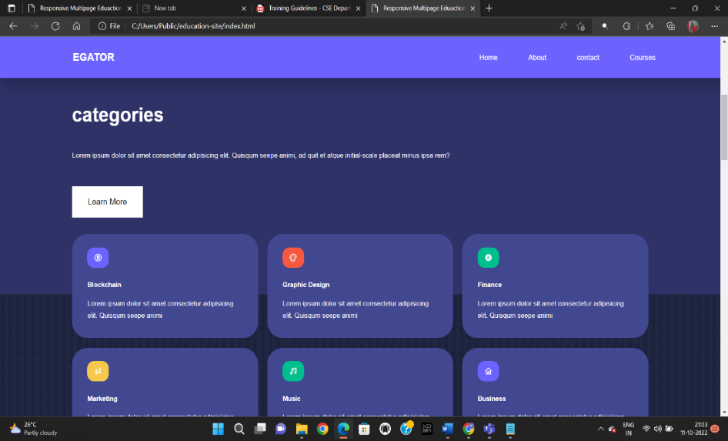

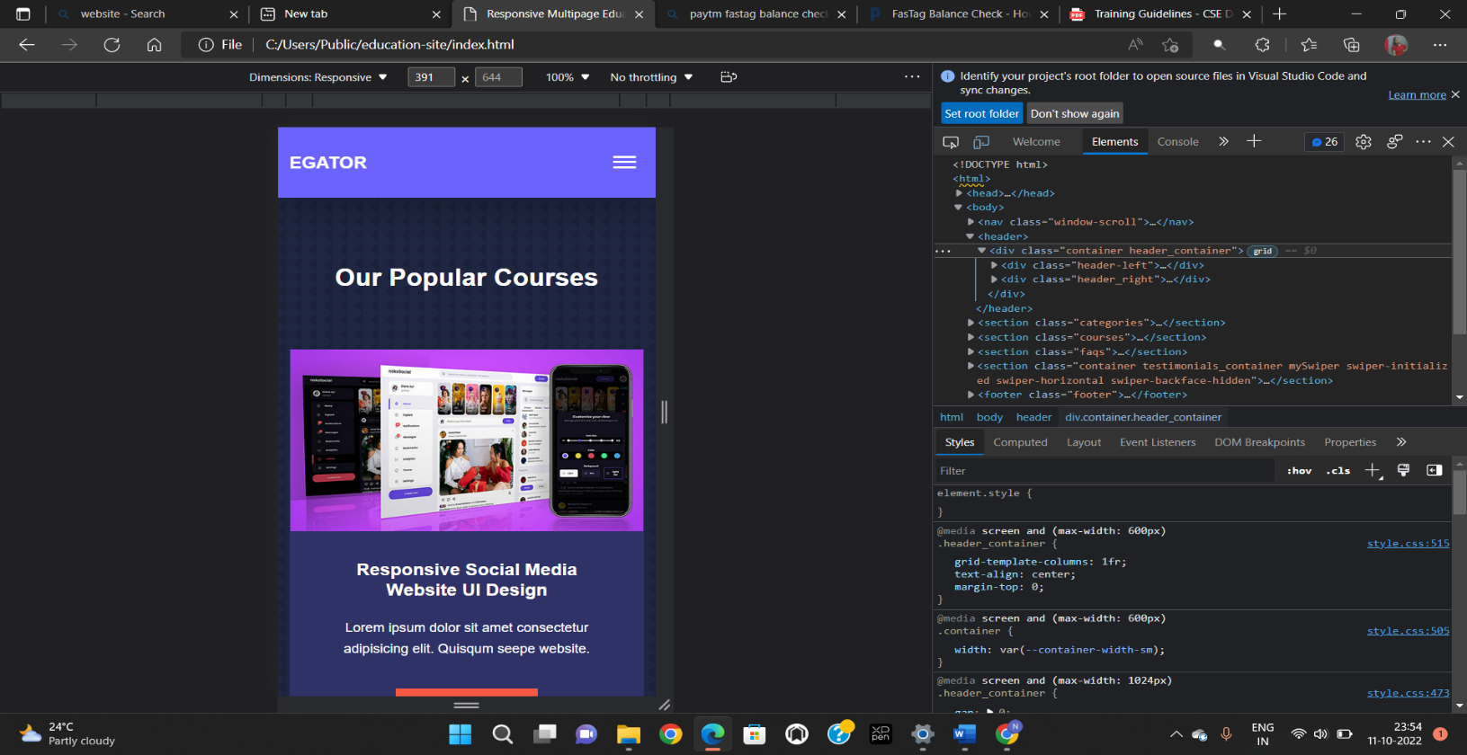

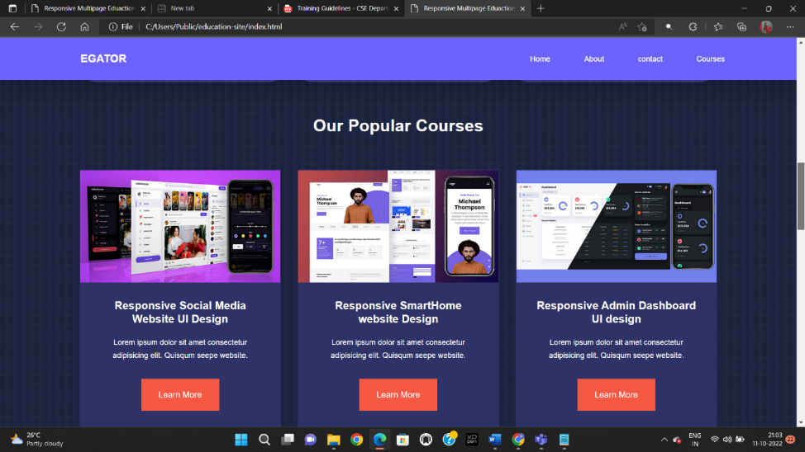

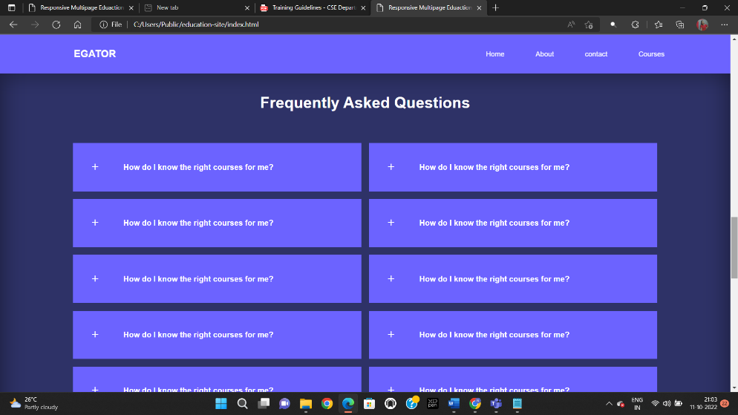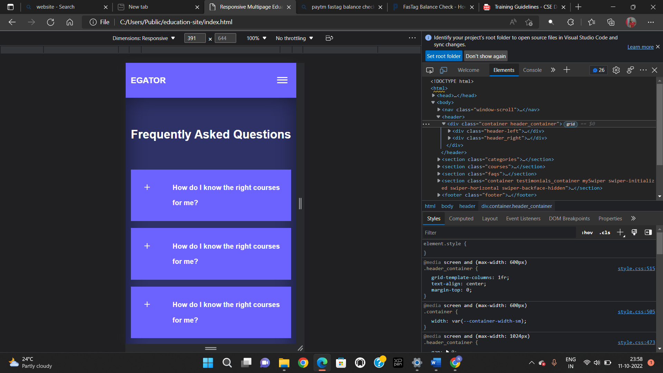

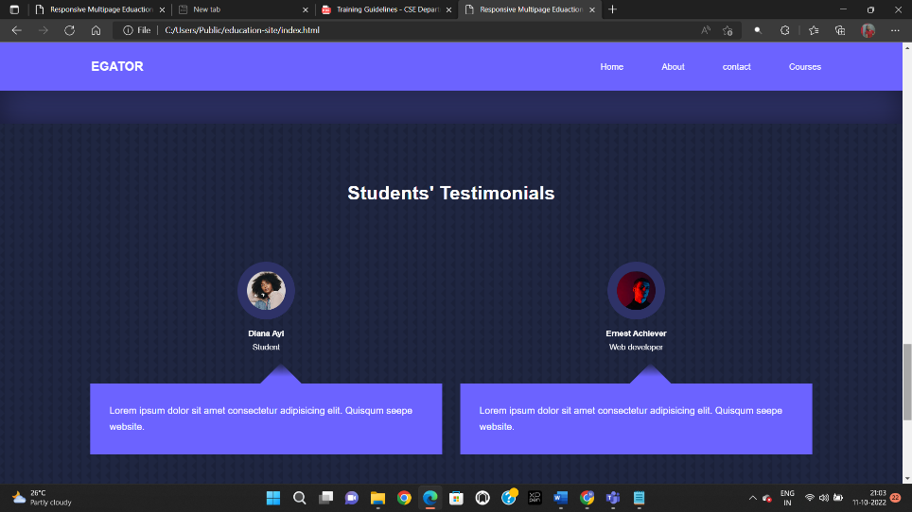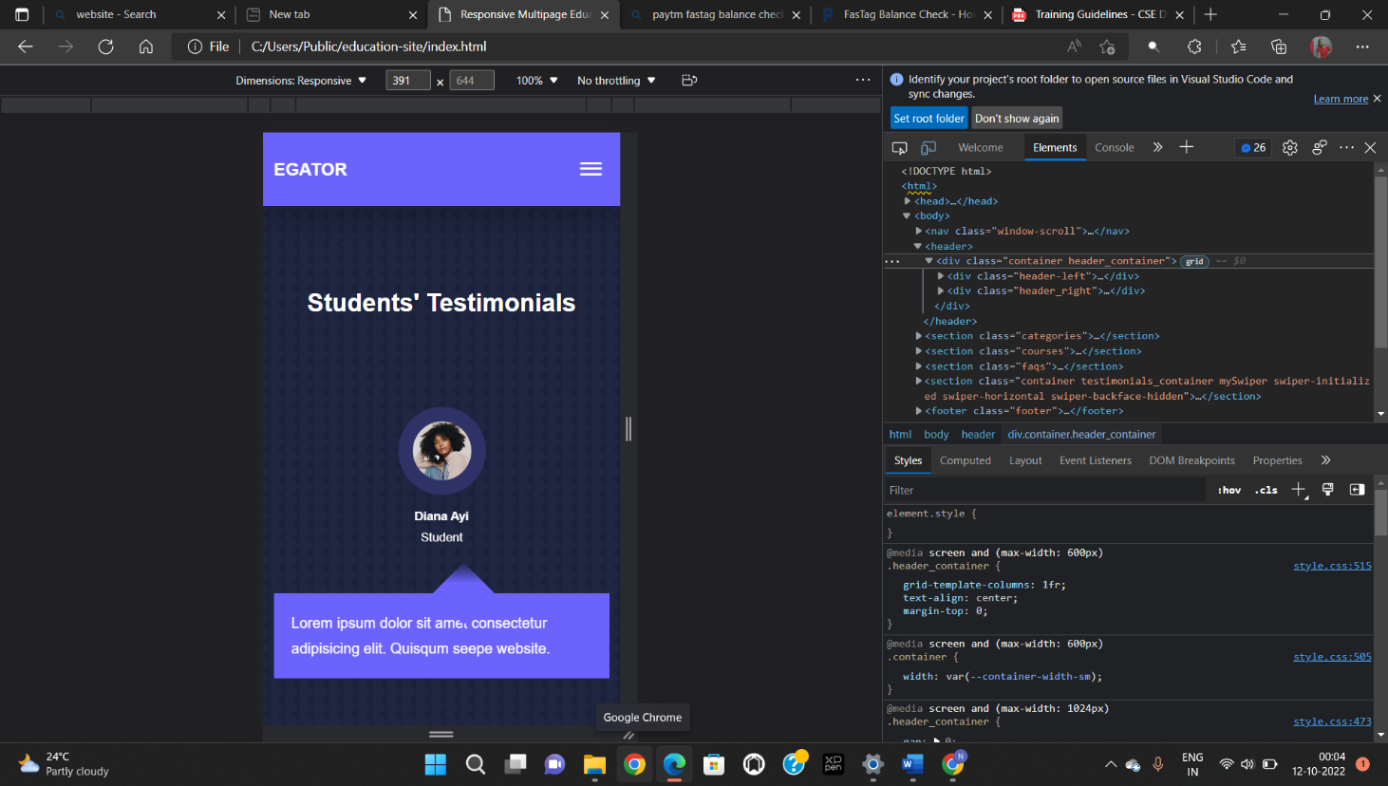

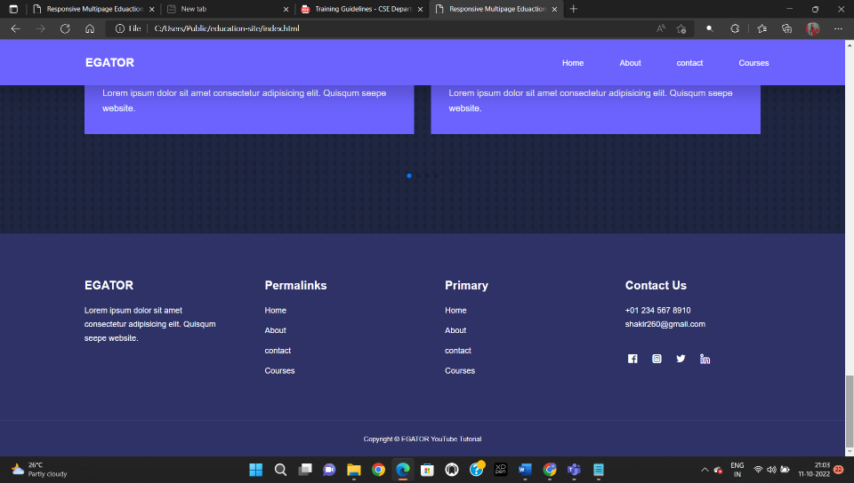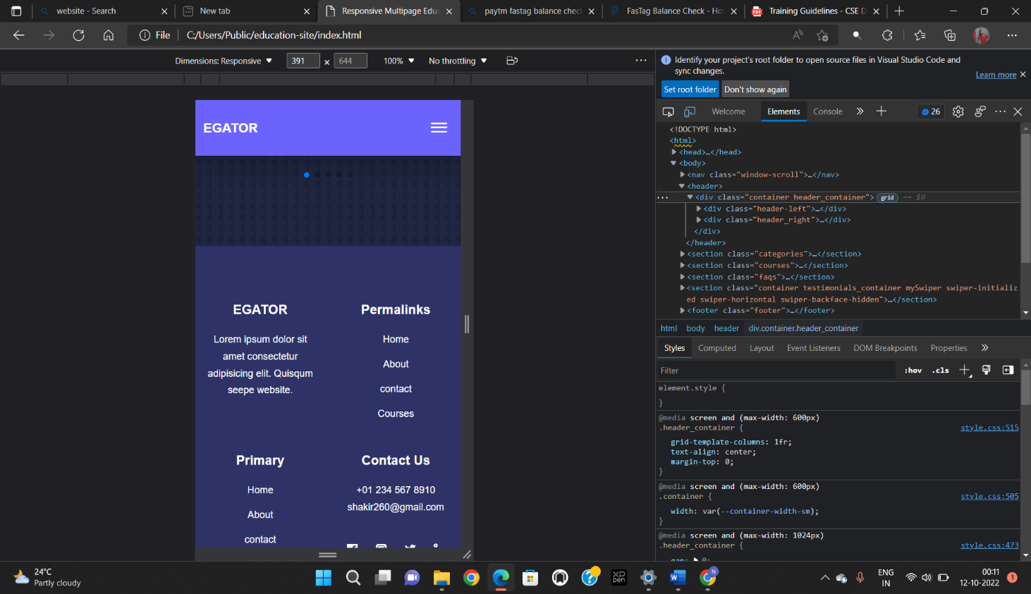

#### **Page-2: About**

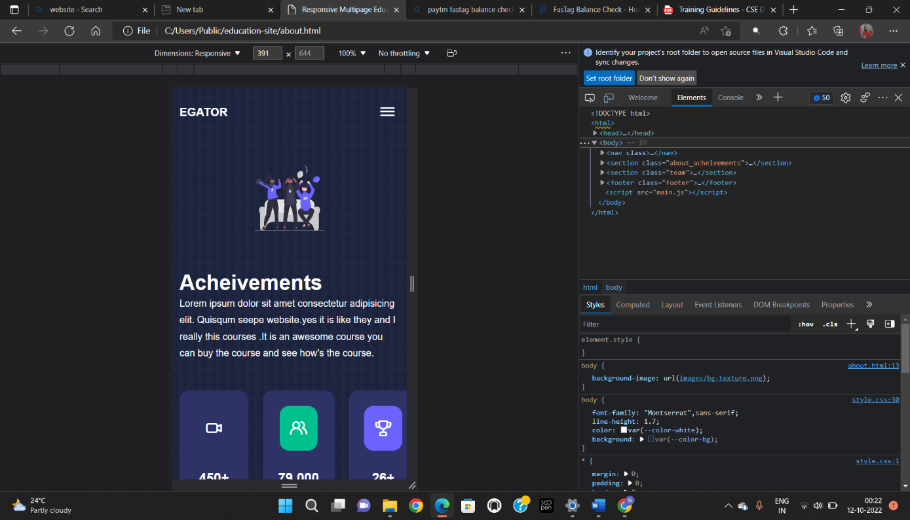This page contains navigation bar, achievements information of teachers and contact details at the end.

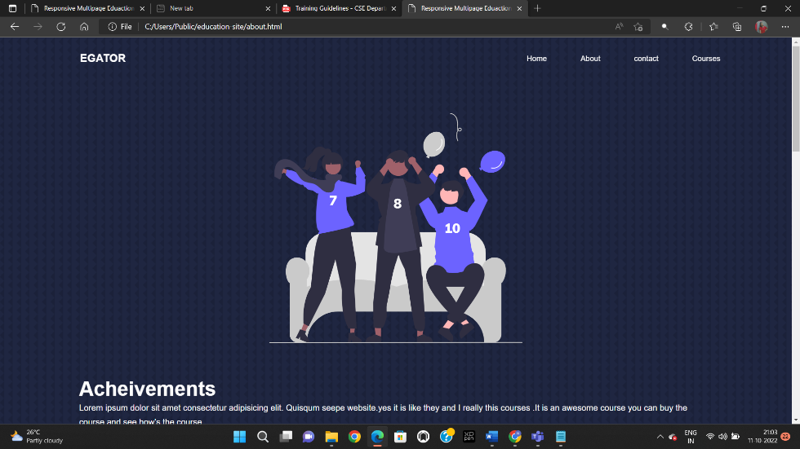

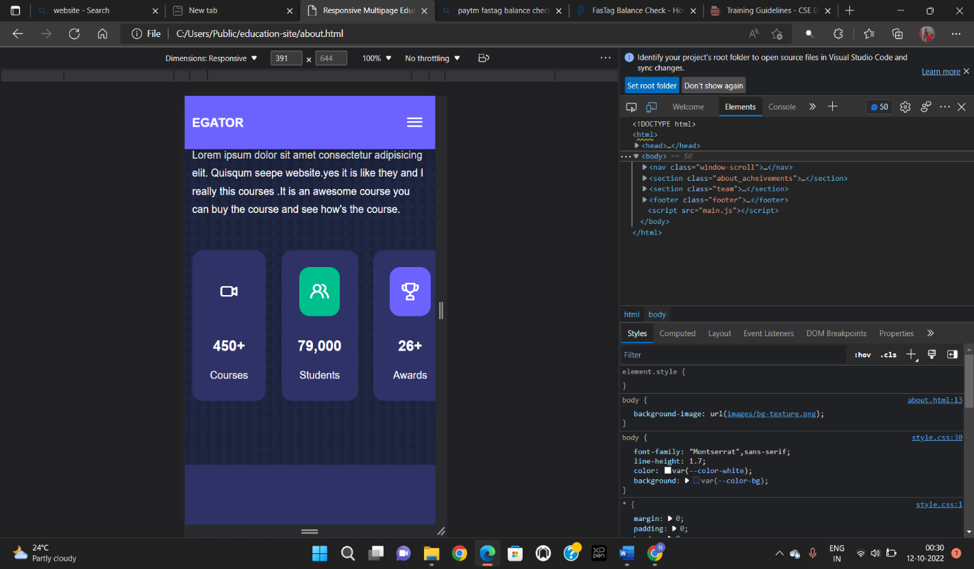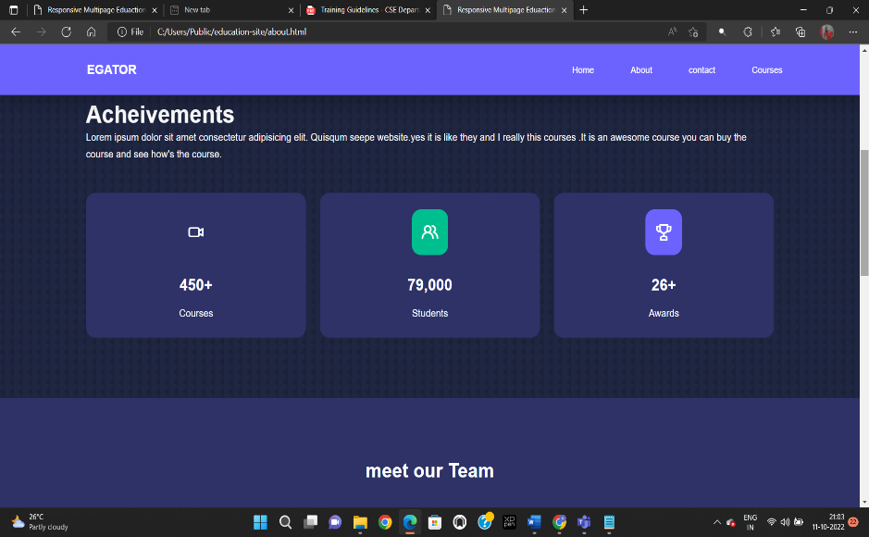

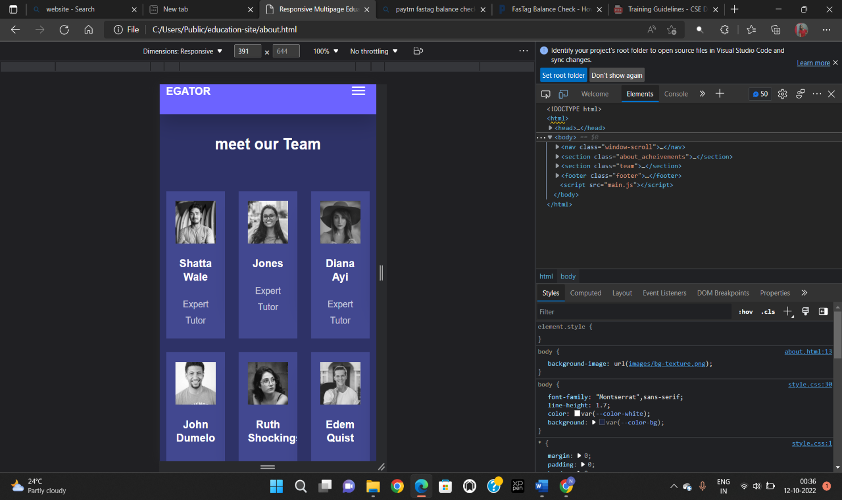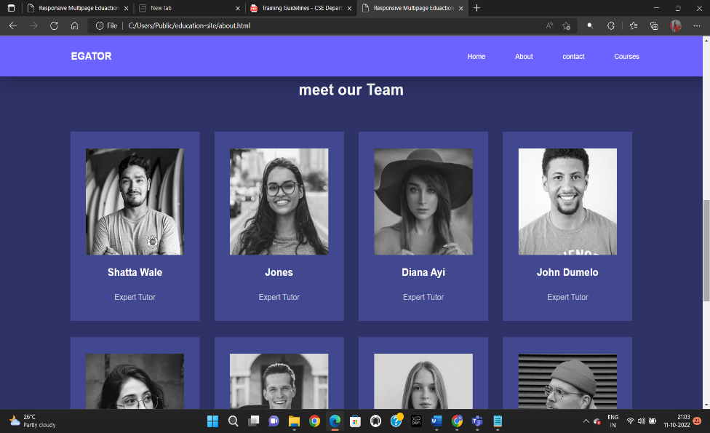

**Page-3: Contact**

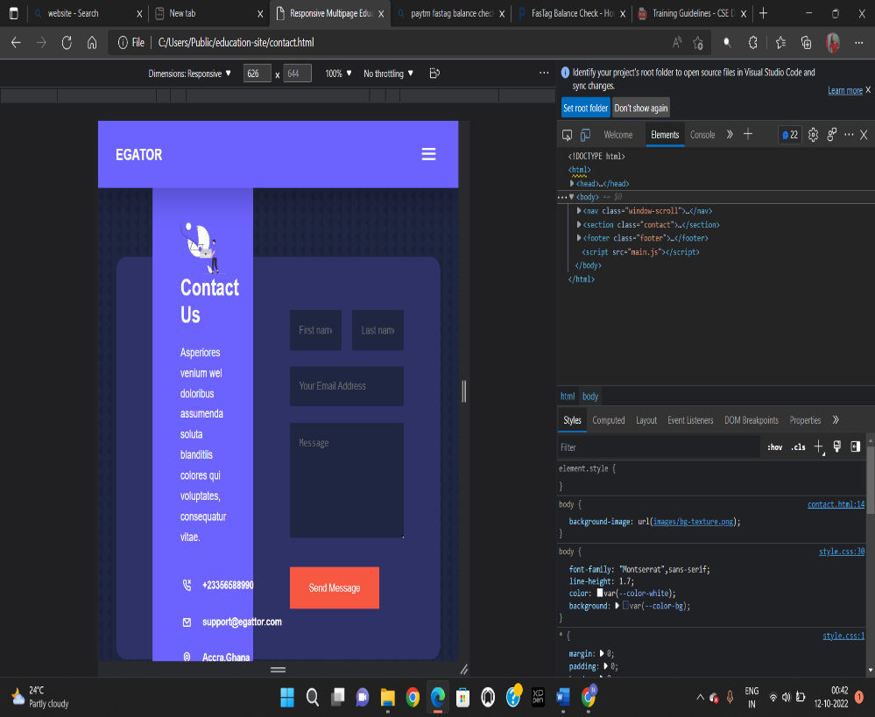This page contains contact information for doubt or query.

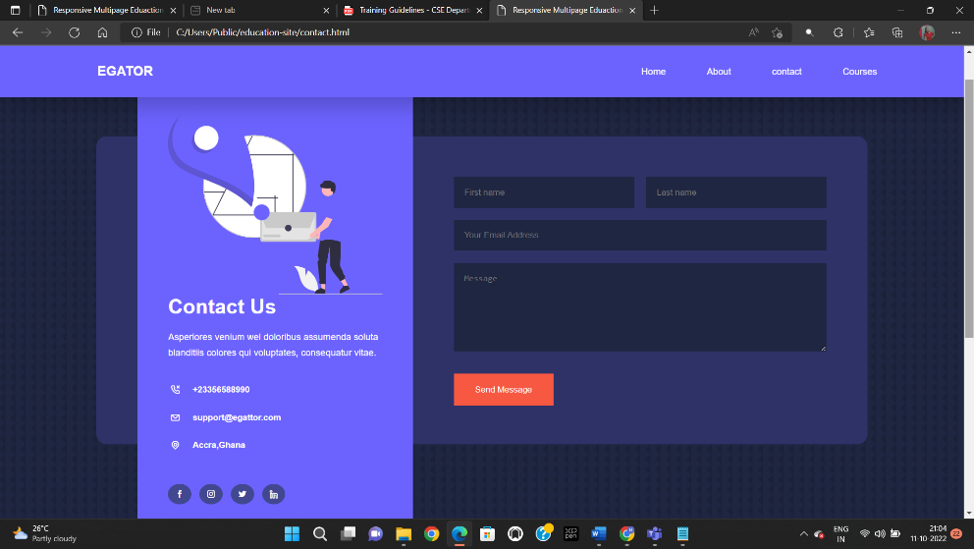

**Page-4: Courses**

**Page-4: Courses**

This page contains different courses for learners.

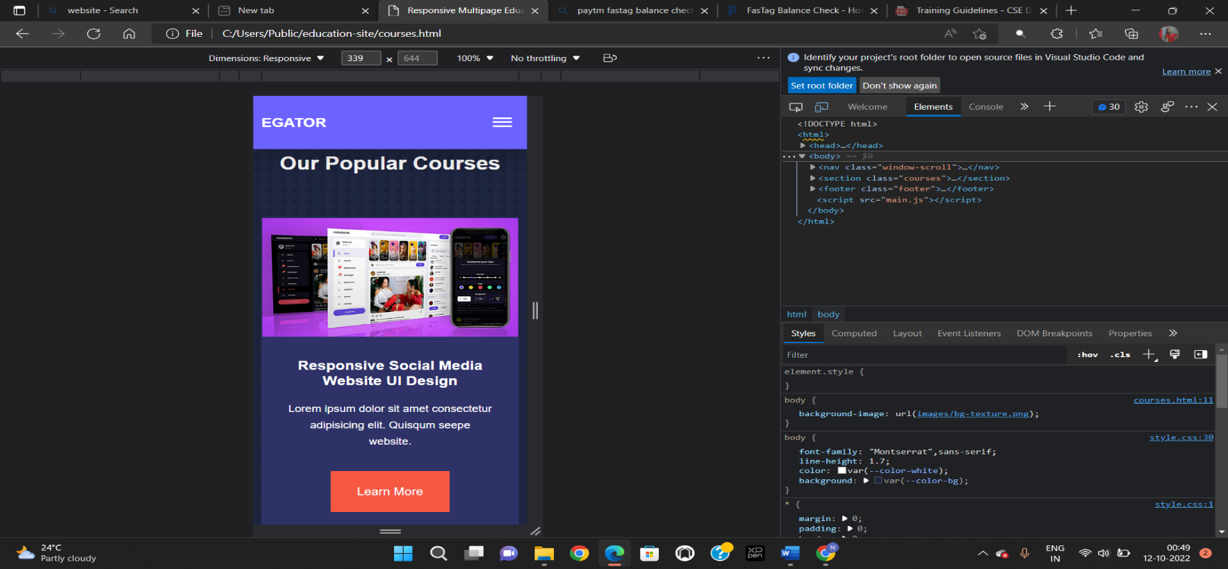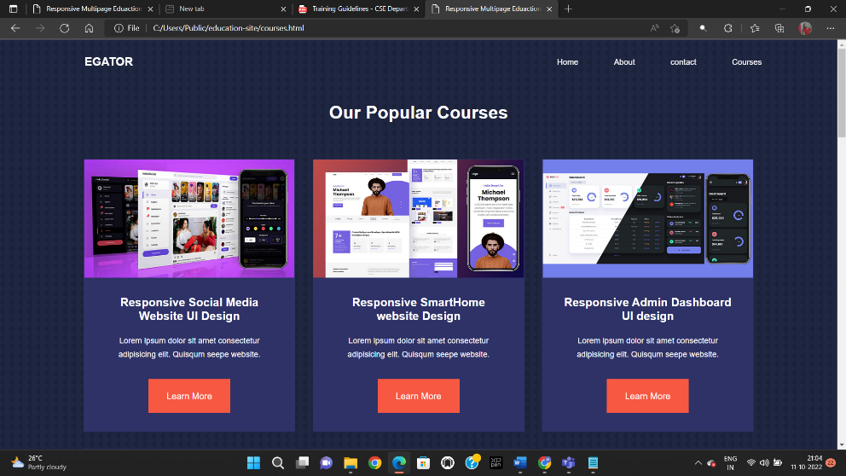

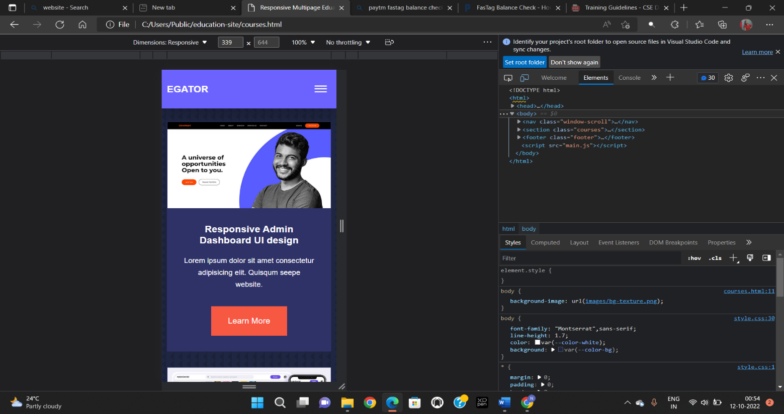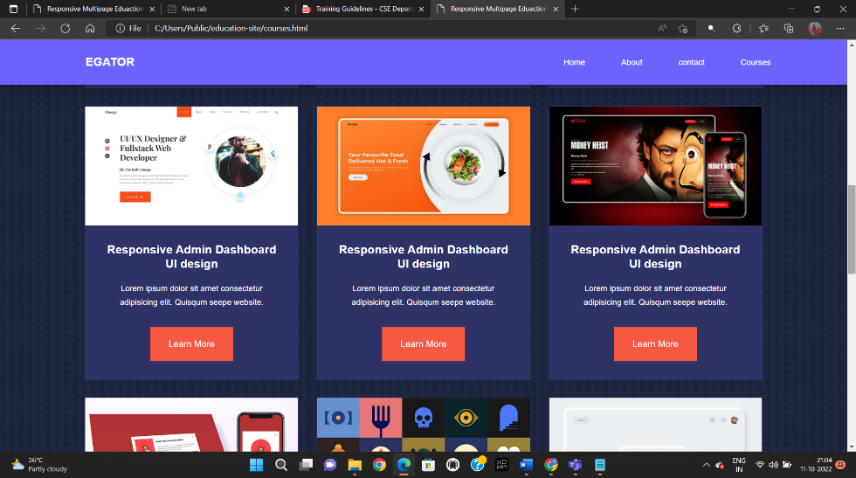

**CHAPTER-5**

**Result and Discussion**

**5a. Result**

A front-end programmer designs and builds the visual user interface of apps and websites leveraging web technologies. Currently, there is a plethora of technologies and frameworks available to create visually appealing, fast-loading, and interactive apps or websites. If firms come across a fabulous-looking app or website remember it is made possible thanks to the skills of front-end developers and the various front-end technologies used.

**5b. Discussion**

* **Retaining More Visitors**

As per statistics, websites and apps which lack good front-end design will diminish visitor interest making it unlikely for them to return. On the other hand, skillfully designed frontends make visitors stay on the website. Also, it is more likely to have increased traffic as well as customer conversions.

* **Making a Good First Impression**

Most visitors spend only a few seconds deciding whether to stay on a particular site or switch to some other site. The front end serves as the first look of a company. Hence investing in front-end development makes business sense.

* **Effective Branding**

The front-end serves as a tool to market your organization. It inspires trust as well as confidence in prospective clients. A visually attractive and well-organized GUI makes for an effective advertisement for your brand.

* **Offer Ease of Use**

Today’s customers prefer user-friendly sites. The front end should be simple and convenient to use. Also, the navigation needs to be intuitive and seamless. The GUI should not be cluttered and offer a superior User Experience.

* **Responsive Design**

Currently, there is a vast variety of hardware and operating systems. This trend is likely to persist in the future. The front end should be compatible with any kind of device or operating system.

* **Fast load time**

Most users don’t have patience with sluggish websites. The front-end should load quickly and deliver the fast and efficient response to user actions.

**CHAPTER-6**

**Conclusion And Future Scope**

**6a. Conclusion**

With the advancement of web and internet, it is becoming so ease for end user to use web based services.

**6b. Future Scope**

The EGATOR platform in web based and does not takes time to get Hugh traffic. For making the system more stable and face more competition from similar product, it must add unique and killer features to the website. This is the age of artificial intelligence and machine learning. Visitor does not want to waste their time on searching the classes what they are looking for. We can use AI and Machine learning algorithm to help student to get whatever class they want. It helps on fraud detection on system. There will be many instructor who just came to make money and student can be encounter with those fraud instructor. There can be spam inquiry for classes from student. We are making user to easily register to system which increase the traffic to site but it has several disadvantage. We are not collecting KYC detail of customer. This can lead to serious issue. We can use AI to solve this types of problems in responsive website is becoming very ease and handy to interact with the online platform. The website is needed for covering wide range of users. This website should have more feature. It get access to the native API and caching on local storage save bandwidth and offline access.

**CHAPTER-7**

**Weekly Jobs Summary**

|  |  |
| --- | --- |
| **Week** | **Job Summary** |
| 1 | In first week of training period, I made wireframe of the website and arranged all the images. |
| 2 | In second week of training period, I made the html file of main page of the website(index.html) and design the main page with help of style.css |
| 3 | In third week of training period, I made about page(about.html), contact page(contact.html) and course page(course.html). |
| 4 | In fourth week of training period, I designed all the pages of website with the help of css which were style.css, about.css and contact.css. |
| 5 | In fifth week of training period, I added some functionality with the help of javascript which was main.js file. |
| 6 | In the last week of training period, I used netlify in the project for storing the data of query of the users and after that test the website and after successfully testing I deployed the website at netlify. |

**LEARING AFTER TRAINING**

Hence, after completing the training of Web Development Bootcamp sufficient knowledge was gained to implement the concept of Education website via Front-end Web Development. The website was successfully made and achieved all the set objectives while also providing some real life experience on how to solve real world problems using HTML, CSS and JavaScript. Thus, the project was a success.

I got to learn a lot about how to make yourself useful in real life and using my skills to give shape to the website in my mind. This project while making also taught me how to formally document my work so that it can be presented various experts in the field such as my teachers and mentors. I am thankful for the opportunity provided to complete this project.

**REFERENCES**

* Udemy.com

<https://www.udemy.com/course/the-complete-web-development-bootcamp/>

* Geeks for Geeks

[JavaScript - GeeksforGeeks](https://www.geeksforgeeks.org/javascript/)

* Stack Overflow
* Google.com
* Youtube.com

<https://www.youtube.com/watch?v=HlKBznWcC_k>

[CSS Tutorial In Hindi (With Notes) 🔥 - YouTube](https://www.youtube.com/watch?v=Edsxf_NBFrw&t=37s)

* MDN

[JavaScript | MDN (mozilla.org)](https://developer.mozilla.org/en-US/docs/Web/JavaScript)

[HTML: HyperText Markup Language | MDN (mozilla.org)](https://developer.mozilla.org/en-US/docs/Web/HTML)

[CSS: Cascading Style Sheets | MDN (mozilla.org)](https://developer.mozilla.org/en-US/docs/Web/CSS)